**NOISE POLLUTION MONITERING SYSTEM USING**

**ESP8266**

**INTRODUCTION:**

**We surely can’t imagine a world without sound. Sound is one of an integral part of our day to day life, everything just becomes monotonous without the presence of audio. But too much of anything is dangerous, with the advent of automobiles, loudspeakers, etc. sound pollution has become a threat in recent days. So, in this project, we will build an IoT decibel meter to measure sound in a particular place and record the value in a graph using IoT.**

**REQUIRED COMPONENTS:**

* **Microphone sensor(Sound sensor)**
* **16*2 LCD Module**
* **Breadboard**
* **Connecting wires**
* **ESP8266 NodeMCU Board**

**SOUND SENSOR:**

### SOUNSOUND

**How does Microphone Module Work?** r is **The microphone based sound sensor is used to detect sound. It gives a measurement of how loud a sound is. The sound sensor module is a small board that mixes a microphone (50Hz-10kHz) and a few processing circuitry to convert sound waves into electrical signals. This electrical signal is fed to on-board LM393 High Precision Comparator to digitize it and is made available at the OUT pin.**

**The connections are pretty simple, we just have to connect the sound sensor to one of the Analog pin and the LCD to the I2C pins. In the above diagram, we have connected the power pins of the sound sensor and LCD display to 3v3 and GND pin of NodeMCU. Along with that, we have also connected the SCL and SDA pins of the module to D1 and D2 respectively, and the OUT pin of the sound sensor to A0 pin.**

**Circuit Diagram for IoT Sound Meter**

### METER (50 POLLUTION This

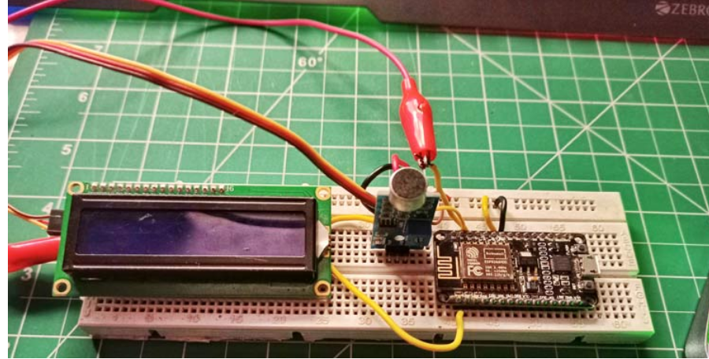 **Comparator** to digitize it **CODE:**

**#define BYYNK_PRINT Serial**

**#include <ESP8277Wifi.h>**

**#include <BlynkSimpleEsp8266.h>**

**#include<LiquidCrystal_I2C.h>**

**#define SENSOR_PIN A0**

**LiquidCrustal_I2C Icd(0x3F,2,1,0,4,5,6,7,3, POSITIVE);**

**Const int sampleWindow = 50;**

**Unsigned int sample;**

**Int db;**

**Char auth[]=“IEuIxT825VDt6hNfrcFgdj6inj1QUfsA”;**

**Char ssid{}=“real 6”;**

**Char pass[]=“evil@zeb”;**

**BLYNK_READ(V0)**

**{**

**Blynk.virtualWrite(V0,db);**

**}**

**Void setuo() {**

**pinMode(SENSOR_PIN, INPUT);**

**Icd.begin916,2);**

***Icd..backlight();***

***Icd.clear();***

***Blynk.begin(auth, ssid,pass);***

***}***

***Void loop() {***

***Blynk.run();***

***unsigned long startMillis = millis(); // Start of sample window***

***float peakToPeak = 0; // peak-to-peak level***

***unsigned int signalMax = 0; //minimum value***

**unsigned int signalMin = 1024; //maximum value**

**While (millis() – startMillis < sampleWindow)**

**{**

**sample = analogRead()SENSOR_PIN); //get reading from microphone**

**if (sample < 1024) // toss out spurious readings**

**{  
 sample = analogRead(SENSOR_PIN); //get reading from microphone  
 if (sample<1024) // toss out spurious readings  
 {  
 if (sample > signalMax)  
 {  
 signalMax = sample; // save just the max levels  
 }  
 else if (sample < signalMin)  
 {   
 signalMin = sample; // save just the min levels  
 }   
 }**

**peadToPeak = signalMax – signalMin; // max-min = pead-peak amplitude  
 Serial.printIn(peakToPeak);  
 db = map(peadToPeak, 20, 900.49.5,90); //calibrate for deciBels   
 Icd.print(“Loudness;’);  
 Icd.print(db);  
 Icd.print(‘dB”);  
 if(db <=50)  
 {  
 Icd.setCursor(0,1);  
 Icd.print(“Level: Quite”)l  
  
 }  
 else if (db>50 && db<75)  
 {  
 Icd.setCursor(0,1);  
 Icd.print(“Level: Moderate”);  
 }  
 else if(db>=75)  
 {  
 Icd.setCursor(0,1);  
 Icd.print(“Level: high”);  
 }  
 delay(600);  
 Icd.clear();  
 }**

**analysis**

nalysis

**List of trees to be planted to reduce**

**Noise pollution levels**

**1. Mango**

**2. Neem**

**3. Australian Acacia**

**4. Fountain**

**5. Bamboo**

**6. Ward**

**7. Pimpal**

**Factors responsible for noise pollution**

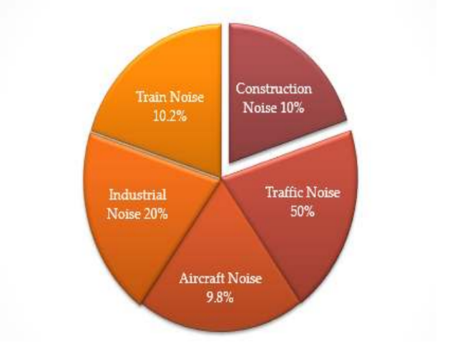

Conclusion

Conclusion

Conclusion

Conclusion

Conclusion

**conclusion**

**Conclusion**

**What is noise pollution? The concept of**

**noise pollution was understood.**

**The detailed information about the effects on the environment due to increasing noise pollution was collected.**

**Got more information about the factors that cause noise pollution.**

**Obtained and collected information about the proposed measures to reduce noise pollution**

Conclusion

### convert sound waves into electrical signals. This electrical signal is fed to on-board LM393 High Precision Comparator to digitize it and is made available at the OUT pin.

MICHOHUJUYHNBYTHBHJURHOW DOES MICROPHONE MODULE HOW DOES MICROPHONE MODULE SENSOHOW DOES MICROPHONE MODULE